Cybersecurity in Weather & Incident Alerts for Travel App (Jharkhand)

# 1. Introduction

Travelers in Jharkhand face unpredictable weather such as monsoon floods, thunderstorms, and heatwaves, as well as local incidents like road closures, landslides, and forest fires. A travel app providing real-time weather and incident alerts can improve safety. However, the app must implement cybersecurity measures to ensure alerts are accurate, authentic, and secure, while protecting traveler data.

# 2. How Cybersecurity Works in the App (Jharkhand Examples)

## 2.1 Secure Data Transmission

Problem: Data like traveler location or weather alerts can be intercepted.  
Solution: All communication between the app, server, and APIs is over HTTPS/TLS.  
Jharkhand Example: When a traveler in Ranchi receives flood updates from IMD or local government sources, the data is encrypted during transmission to prevent attackers from accessing it.

## 2.2 Secure Storage of Sensitive Data

Problem: Traveler locations, preferences, and API keys can be stolen if stored insecurely.  
Solution: User location and alert preferences are encrypted using AES-256. API keys for weather sources are stored securely using AWS Secrets Manager. Access control ensures only the server can read sensitive data.  
Jharkhand Example: A traveler in Hazaribagh has their preference for “Severe thunderstorm alerts” stored securely, so only relevant alerts are sent.

## 2.3 Data Validation and Integrity

Problem: Alerts could be falsified or tampered with.  
Solution: Validate API data using JSON schemas. Use digital signatures/checksums to verify authenticity. Cross-check alerts against multiple sources (IMD + Jharkhand State Disaster Management).  
Jharkhand Example: A landslide alert for Giridih is verified with both local authorities and IMD before notifying travelers.

## 2.4 Threat Detection & Prevention

Problem: Attackers may try to send fake alerts or flood the system.  
Solution: Intrusion Detection Systems (IDS) monitor abnormal activity. Bot protection/CAPTCHA prevents automated attacks. Geo-fencing ensures alerts are sent only to users physically in the affected area.  
Jharkhand Example: If someone tries to trigger a fake flood alert in Bokaro, IDS and rate-limiting block the request.

## 2.5 Real-Time Alert Security

Problem: Alerts must reach travelers immediately and securely.  
Solution: Push notifications via FCM/APNS are encrypted end-to-end. Critical alerts (floods, storms) are prioritized. Tamper-proof alerts carry secure signatures.  
Jharkhand Example: A storm alert in Jamshedpur pops up instantly on a traveler’s phone with verified content.

## 2.6 User Authentication & Access Control

Problem: Unauthorized users can compromise alerts or access data.  
Solution: Secure login via email, phone OTP, or social login. Admins updating alert sources use multi-factor authentication (MFA). Role-based access ensures only verified personnel update critical alerts.  
Jharkhand Example: Only verified personnel from the Jharkhand State Disaster Management Authority can update flood warnings for Ranchi district.

## 2.7 Continuous Monitoring & Updates

Problem: Cyber vulnerabilities or outdated systems can compromise security.  
Solution: Regularly patch APIs, libraries, and servers. Monitor anomalies like unusual spikes in alert requests. Extra monitoring during monsoon or high-risk seasons.  
Jharkhand Example: During the monsoon, extra monitoring ensures that landslide alerts in Koderma or Giridih reach travelers without interference.

# 3. How Travelers Access the App in Jharkhand

3.1 Download and Install: Install from Google Play Store or Apple App Store. Ensure the latest version is used to receive accurate alerts.

3.2 Enable Location Services: GPS tracking provides real-time alerts. Optionally, manually select districts like Ranchi, Jamshedpur, Hazaribagh, Bokaro, Giridih, or Koderma.

3.3 Set Alert Preferences: Choose types of alerts (Weather: rain, storm, heatwave; Incidents: floods, road closures, landslides, accidents). Set severity levels (high, medium, low).

3.4 Receive Real-Time Alerts: Push notifications appear for critical events. Dashboard or map view shows current location and nearby incidents.

3.5 Safety & Travel Guidance: Provides safe routes, emergency contacts (police, hospitals), and short-term forecasts.

3.6 Offline Access: Critical alerts may be cached for offline use in remote areas of Jharkhand with poor network coverage.

# 4. Summary

Cybersecurity in a Jharkhand-focused travel app ensures:  
- Weather and incident alerts are authentic, tamper-proof, and timely.  
- Traveler location and preferences are encrypted and protected.  
- Real-time notifications are secure and specific to Jharkhand districts.  
- Travelers can safely access alerts while traveling in Jharkhand, staying informed about floods, storms, landslides, and other incidents.

# 5. API Flowchart & Working

The flowchart below explains how the API securely delivers weather and incident alerts in the travel app for Jharkhand:  
  
1. Traveler (User): The user enables location services or manually selects their district (e.g., Ranchi, Jamshedpur).  
2. Mobile App: The app sends a request for weather or incident alerts to the secure API using HTTPS/TLS encryption, ensuring the data cannot be intercepted.  
3. Secure API: The API acts as a bridge between the app and official alert sources (e.g., IMD, Jharkhand State Disaster Management Authority). It verifies, encrypts, and processes the data to prevent tampering.  
4. Weather/Incident Alerts: The API fetches verified alerts (floods, storms, landslides, road closures) and sends them back to the app securely. Critical alerts are sent via encrypted push notifications.  
5. Secure Communication (HTTPS/TLS): Ensures all data (location, preferences, alerts) is transmitted safely without being intercepted by attackers.

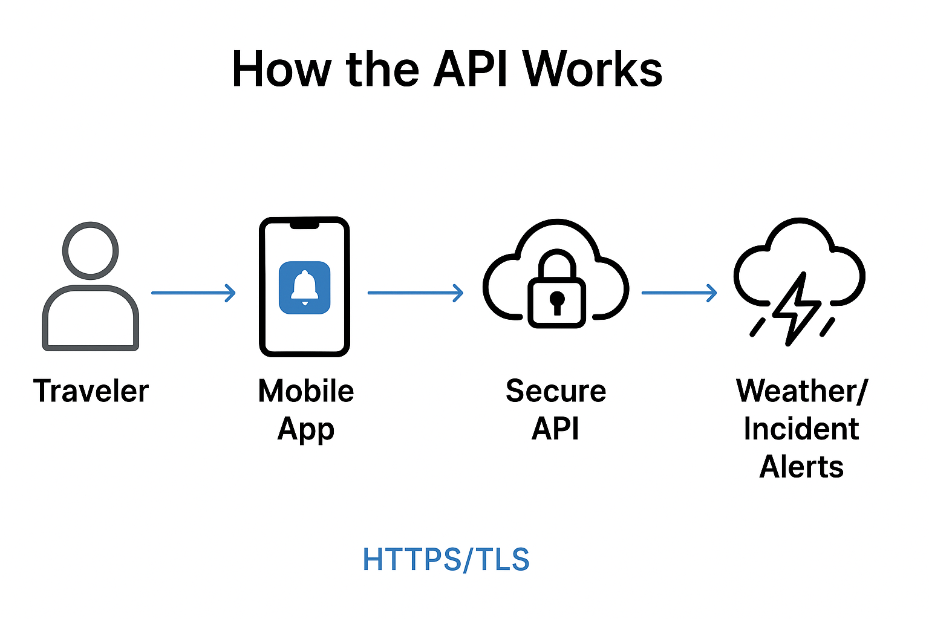

Cybersecurity in Travel Apps – Introduction

Cybersecurity in travel applications plays a vital role in protecting sensitive traveler information, ensuring data authenticity, and providing secure communication between the user, app, and data sources. This is especially important in regions like Jharkhand, where real-time weather and incident alerts (floods, storms, landslides) can directly impact traveler safety. Implementing cybersecurity ensures that alerts are accurate, tamper-proof, and delivered without delay.